1：solving the curve equation by iteration methods，Newton method，secant method（Based on x**2-2*x function），You can see these algorithms （ iteration methods，Newton method，secant method ）ahead of time

import numpy as np
import matplotlib.pylab as plt
X=[1,2,3,4,5,7,8,9]
y=[np.log(x) for x in X]
def Newton(X,y):
W=np.zeros([len(X),len(X)+1])
W[:,0]=X
W[:,1]=y
for i in range(W.shape[1]-2):
for j in range(i,W.shape[0]-1):
W[j+1,i+2]=(W[j+1,i+1]-W[j,i+1])/(W[j+1,0]-W[j-i,0])
def f(x):
res=W[0,1]
c=1
for i in range(1,W.shape[0]):
a=W[i,i+1]
c*=(x-X[i-1])
res+=a*c
return res
return f
f=Newton(X,y)
plt.scatter(X,y)
x=np.arange(1,9,0.1)
plt.plot(x,f(x))
plt.show()
plt.figure()
X=[1,2,3,4,5,7,8,9]
y=[x**2 for x in X]
f=Newton(X,y)
plt.scatter(X,y)
x=np.arange(1,9,0.1)
plt.plot(x,f(x))
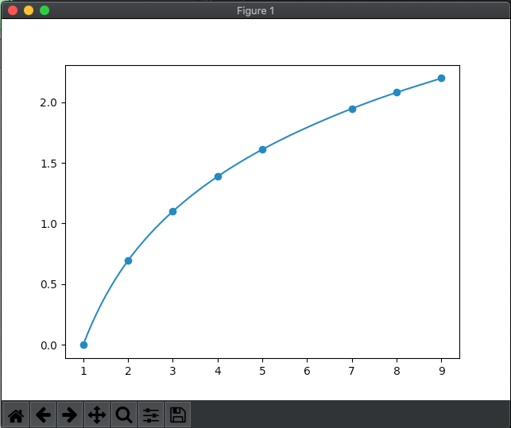
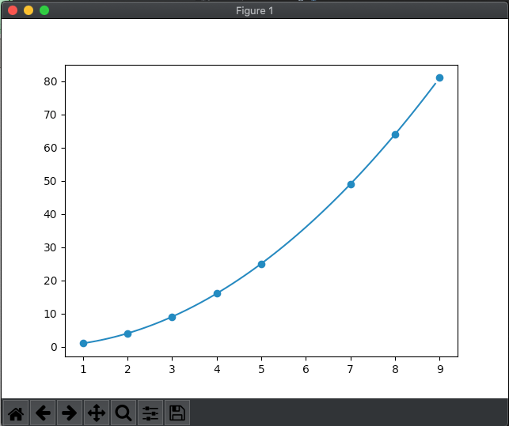

2：Randomly generate 200 card Numbers；
The card number begins with 6102009， The next three are in order（001， 002， 003， 200），
Generate a dictionary about the bank card number, default each card number of the initial password is "redhat";
Output card number and password information
import random
Card_ids = []#Define an empty list
for i in range(1, 201): ##Generate a number from 1 to 200
s = '6102009%0.3d' % i #Set the first few to 6102009, the last three digits of 001 mode
Card_ids.append(s) #Add elements to the defined empty list
Card_dict = {}.fromkeys(Card_ids,'redhat')
print('card number\tpassword') ##Generate the dictionary, the key with different bits corresponds to the same value, and from
for k in Card_dict:
print(k, Card_dict[k])
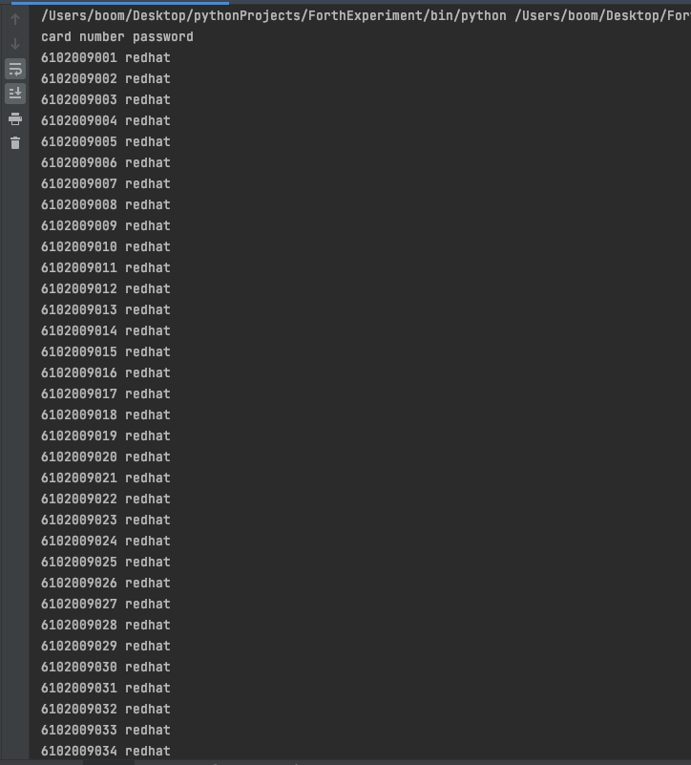
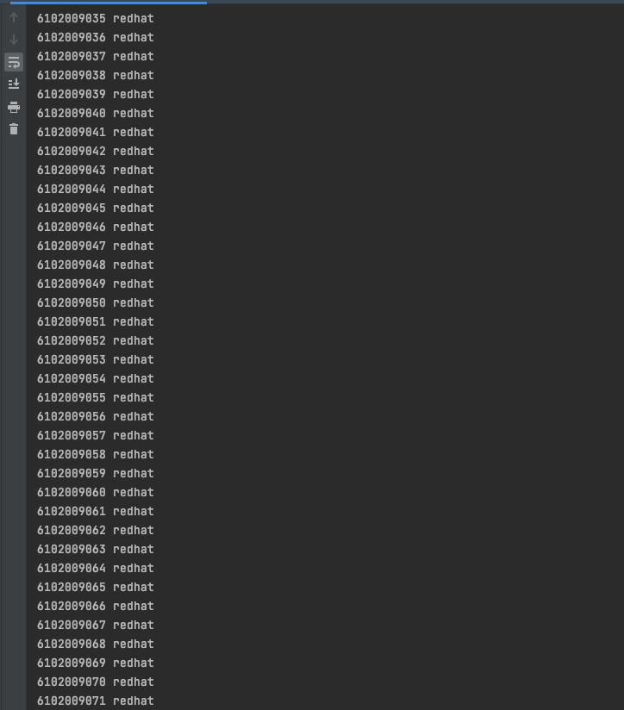
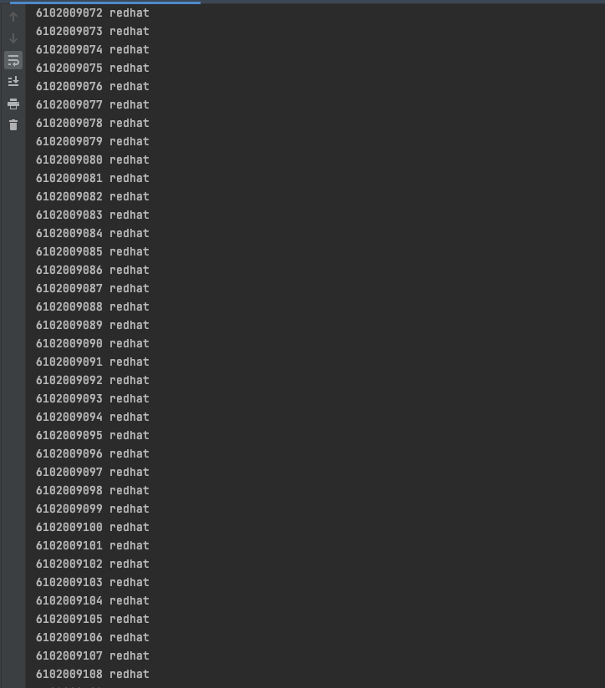
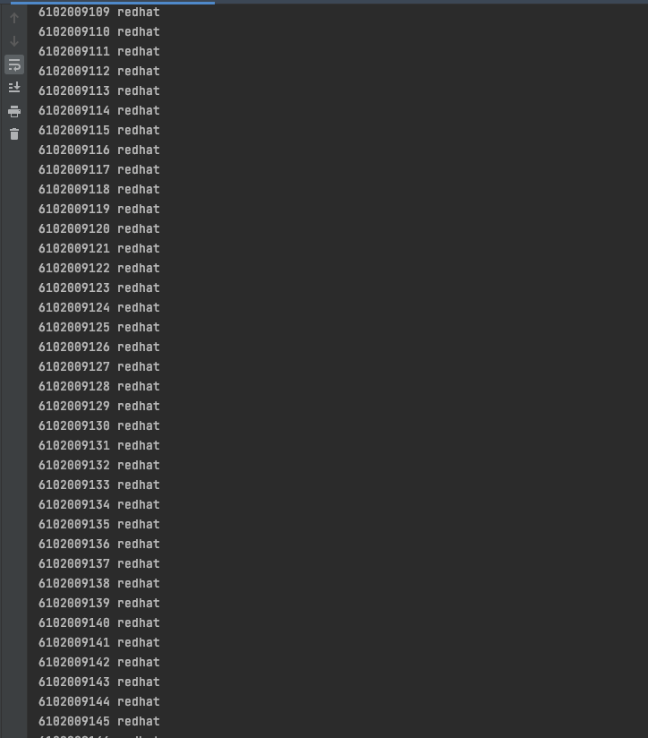
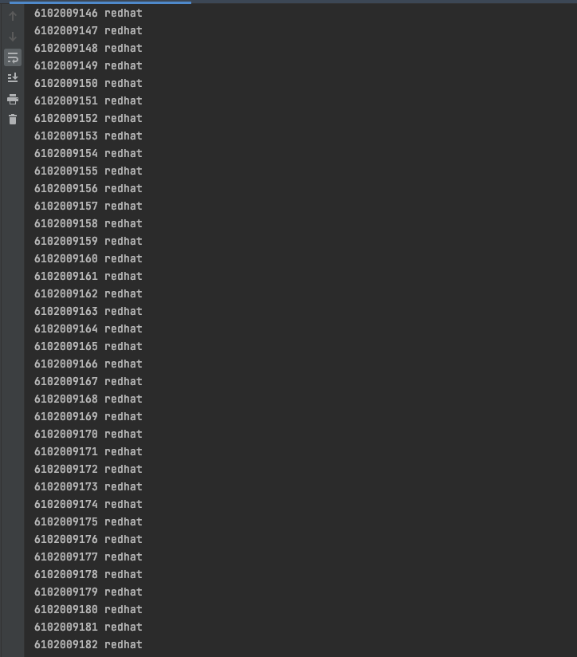
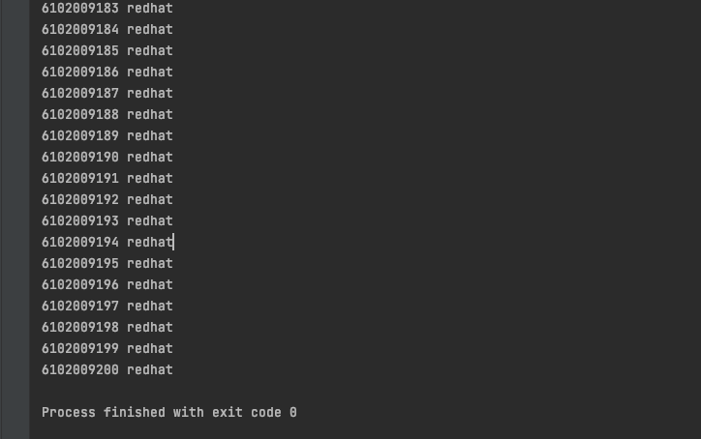
Generating the card numbers randomly (not in order)
import random
Card_ids = []#Define an empty list
for i in range(1, 201): ##Generate a number from 1 to 200
s = '6102009%0.3d' % i #Set the first few to 6102009, the last three digits of 001 mode
Card_ids.append(s) #Add elements to the defined empty list
Card_dict = {}.fromkeys(Card_ids,'redhat')
print('card number\tpassword') ##Generate the dictionary, the key with different bits corresponds to the same value, and from
for k in Card_dict:
random_password = random.choice(Card_ids)
print( random_password, Card_dict[k])
